- About PM MITRA Park Amravati, Maharashtra (static)

Salient features:  - Land area: 1020 acres (~4.13 sq. km)  - Project cost: INR 1,492 Cr (~166 USD million)  - GoI grant: INR...Cr (..m USD)  - Implementation model: Brownfield SIA (MIDC)  Offerings:  - Industrial plots : 620 acres  - Plug-and-Play Units  - Water Supply and Drainage  - Power Infrastructure  - Solar Power Plant  Features:  - CETP (10 MLD)  - STP (2 MLD) with Sewerage system  - Training Centre  - Workers’ accommodation  - Plug & Play Units  - Administrative Office  - SCADA , etc.  Competitive costs:  - Power: Rs 4.5 / unit  - Water: Rs 25 / KL  Projected outcomes:  - Direct jobs: 50,000  - Investment: INR 6000+ + Cr (723 M USD)  - Sustainability rating: (coming soon) | Video (required from state)/ CM Tweet/ pic/ launch pic of PM& CM

- Connectivity (static)
- Road Connectivity – Connectivity to Mumbai–Nagpur Expressway (30 km)
- Railway – Amravati Railway (25 km), Badnera Railway (35 km), Walegaon Railway (43 km)
- Airport – Amravati Airport (42 km), Nagpur Airport (138 km), Mumbai Airport (710 km)
- Seaport – Jawaharlal Nehru Port Trust (697 km), Mumbai Port Trust (701 km)

- Site progress (dynamic) –
Land and site development | Access roads | Water Supply (external) | Water Supply (internal) | Power | CETP
Photo from state | Photo from state | Photo from state |  | Photo from state | Photo from state
Applications invited for land allotment | External Approach Road | Water supply pipeline under construction |  |  | 5 MLD CETP available being upgraded to ZLD
Skill Development Centre – construction completed | Internal road under construction |  |  |  | 15,000 CBM³ effluent sump construction completed

- The PM MITRA Park Amravati, Maharashtra edge (static)

Land | Fully planned trunk infrastructure including roads, drainage, power, water, and common amenities.
EoDB | EC and DTCP approvals in place
Entreprenuurial ecosystem | Existing Ecosystem: 14 major textile parks comprising ~631 individual textile units operating within a ~200 km radius of the park  Institutions: Textile Commissioner of India (Mumbai); 7 major textile councils/associations based in Mumbai; The Bombay Textile Research Association (BTRA)
Design and innovation acumen
Sustainability focus | 10 MW Ground Mounted Solar Plant with Energy Storage.

- Facilities –
- Land & Allotment
  - Applications invited for land allotment
  - Land available through MILAAP portal
- Internal & External Connectivity
  - External approach road available
  - Internal roads under construction
- Water Supply
  - External water supply pipeline under construction
  - Basic water infrastructure available on site
- Power Infrastructure
  - Power infrastructure available
  - Infrastructure development works in progress
- CETP & Effluent Management
  - 5 MLD CETP available, being upgraded to ZLD
  - 15,000 CBM effluent sump completed
  - Effluent collection system 80% complete
- Plug-and-Play & Industrial Infrastructure
  - Tenders worth ₹221.73 Cr issued for Phase-I infrastructure including Plug-and-Play facilities
  - Infrastructure works worth ₹180 Cr under implementation
- Skill Development & Common Facilities
  - Skill Development Centre – construction completed
- Project Readiness & Approvals
  - DPR approved on 17.10.2025 by Park Committee
  - First grant-in-aid installment of ₹30 Cr approved
  - ₹135.32 Cr expended so far
  - Basic infrastructure for roads, power and water available on site

- Conducive policy

Capital Investment Support
- Capital Investment Subsidy (CIS):
  - 40% of the basic cost of eligible machinery, up to INR 25 Cr

Mega & Ultra-Mega Project Incentives
- Ultra Mega Projects
  - Investment > INR 1,000 Cr and employment ≥ 2,000
  - 55% capital subsidy up to INR 250 Cr
  - Special package approved by High Power Committee (HPC) chaired by the Chief Secretary
- Mega Projects
  - Investment > INR 100 Cr and employment ≥ 1,000
  - 45% capital subsidy of total project cost
- Large Projects
  - Investment < INR 100 Cr and employment ≥ 500
  - 40% capital subsidy of total project cost

MSME & Sunrise Sector Support
- Sunrise Sector – Technical Textiles
  - Eligible for capital subsidy benefits under the policy framework

Green & Sustainable Production Incentives
- Recycling of Old Textile Products
  - Subsidy @ 50%, up to INR 2 Cr, for new projects set up exclusively for recycling
- Renewable Energy / Solar Projects
  - Capital subsidy equivalent to 12 months of electricity subsidy for solar energy projects

Innovation & R&D Support
- Fund for the promotion of research and development

- Layout - layout snapshot
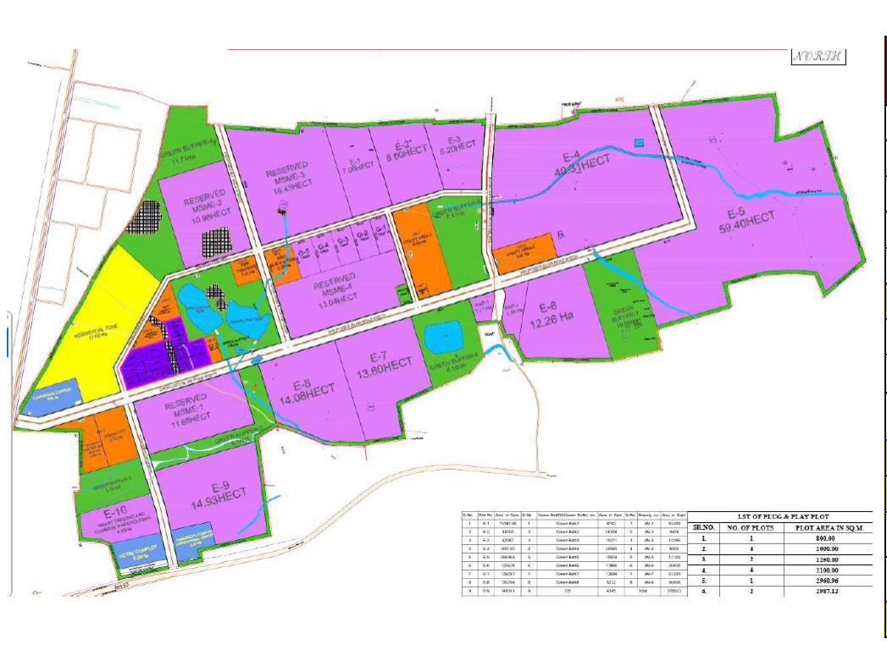

- Tabs for downloads- brochure, land allotment policy, industrial development policy, state textile policy, state msme policy – add links for policy (dynamic)
Tab | Link
Brochure | https://texprocil.org/circular/1689150706-Maharashtra_PM_MITRA_Park-1.pdf
Land Allotment Policy | https://www.midcindia.org/wp-content/uploads/2021/09/Guidelines-on-land-allotment.pdf
Industrial Development Policy | https://maitri.maharashtra.gov.in/policies/
State Textile Policy | https://mahatextile.maharashtra.gov.in/en/document/textile-policy-2023-28-g-r/
State MSME Policy | https://mahasdb.maharashtra.gov.in/files/DSP/Sector/MSMEschemes_8thAugust2023.pdf
Corrigendum | https://texprocil.org/circular/1689150706-Maharashtra_PM_MITRA_Park-1.pdf

- Meet us at (dynamic):
Tab | Link
Investor Summit | https://maitri.maharashtra.gov.in/
Invest India | https://www.investindia.gov.in/state/maharashtra
Road Show | https://maitri.maharashtra.gov.in/wef-2025-mou-updates/

- Links:

Place pic of application invitations (dynamic) | - For land allotment applications- State single window : https://milaap.midcindia.org/PMMitra/Index  - For tenders- https://maitri.maharashtra.gov.in/

- For any queries, connect with (dynamic)
- Write to us:
Name
Company
Query
(system to be created that each query goes to SPV with copy to MoT)

